Linga Scale Menu
Version 1.0

Created Date: July 08th 2017
For the more information, please visit to www.lingapos.com

Table of Contents

Introduction 5
Set Weight Type 5
SeT scale details 5
Number of Digits to Right of Decimal 5
Convert oz to lb 6
Tare Details 6
Attach the Tare Menu 7
Setting Menu 7
OPeration Screen Connect Setting 8
Order Scale Item 10
Unit 11
Tare Weight 11
OPen Tr 11
get TR 11
Preset Tare 11
Price Per QTY 11
Price ITem 11
QTY 11
Done 11
Menu 12

Introduction
Linga introducing new scale menu to calculate the weight and price based on the weight. It is an hardware scale integration to get the weight. Scale will give the weight of the menu item and app will calcualate price and tax for the item based on weight. Also, app should consider the of the container weight (Tare) for the calculation. Yougert, Curd, Ice Creams etc kind of items is our primary goal for calculation.

Set Weight Type
App should provide the option to setup the weight type of the scale. We can show the default values like LB, Gram, KG and OZ in the list box to pickup. We should not allow user to enter the weight type since, app need the control of weight type. We should allow only scale supporting weight types.

SeT scale details
App should allow setup the scale details. We need to get Name, TCP / IP, Port, Channel, Baud Rates (19200), Data Bits (7), Parity (None) and Stop Bits (1).
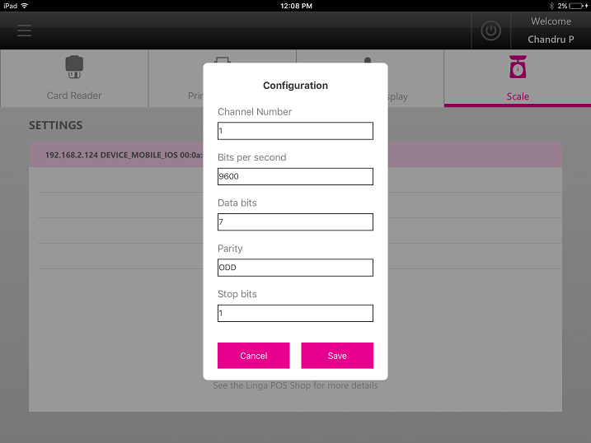

Number of Digits to Right of Decimal
Enter the number of digits that will display to the right of the decimal place for weighted items. This is critical for pound and kilogram scales.

Convert oz to lb
If enabled, ounce scales will show measurements as pounds. In BO, User can see LB, OZ, GM and KG in the serving size levels.App will create these values by default and user cannot change or add the scale values.

Tare Details
App should provide the option to enter name and weight of the tare. Tare value should be in the decimal value. User can create more than one tare values in group. Default is the key if didn’t set the tare to a scale menu, app will automatically use this default tare group.
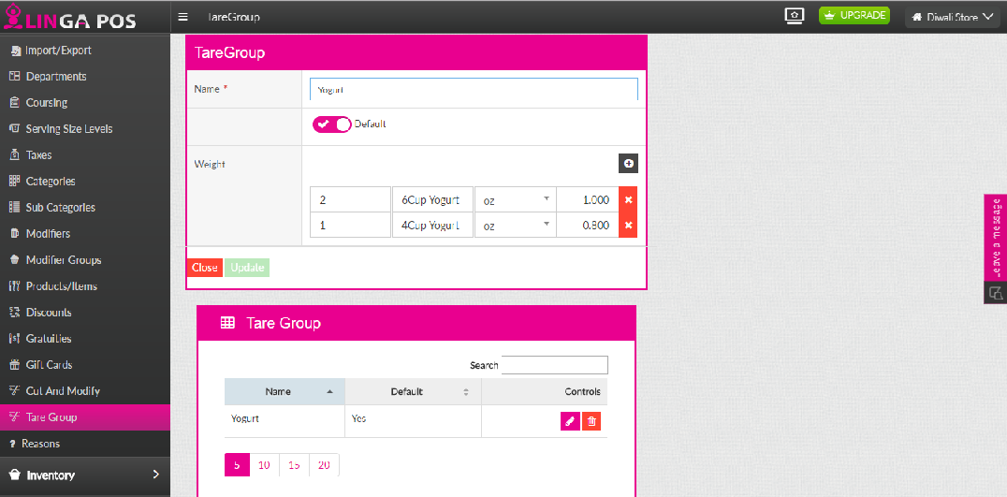

Attach the Tare Menu
Attach the tare with scale menu item or category or subcategory. So the list details will display in the order screen. We can attach same tare list to many menu items. App should validate Tare weight type and Scale Weight should be same (ex: Should not allow Scale in LB and Tare In Oz), app should show the popup weight type mismatch.
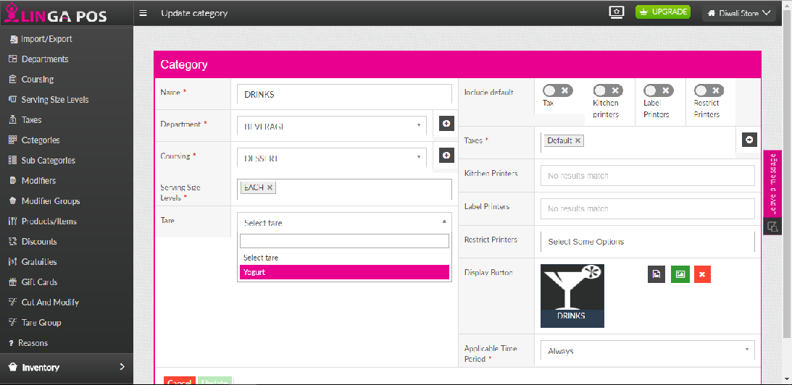

Setting Menu
User should able to select the Menu type as Scale. When user selects the Scale menu type, app should allow selecting the Tare details. Unit Price set per quantity (ex: 1 OZ = $0.02 or 1 LB = $0.03).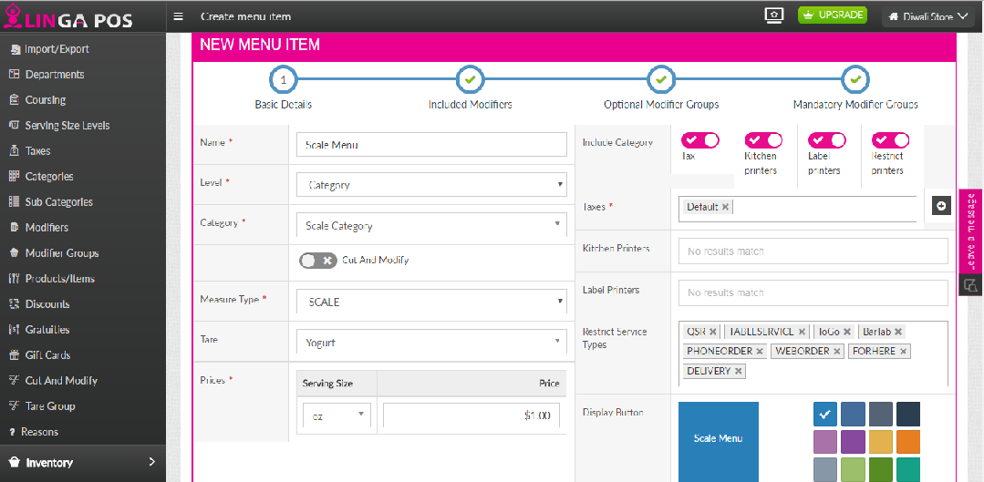

OPeration Screen Connect Setting
Need to place the enable Switch to set Scale. Once switch enabled, Lingaapp have to show the available Scale devices to choose in the iPad Linga App Operation screen. Only authorised user can access this setting screen. Also, it is nice to have to keep the connection testing button for Scale.
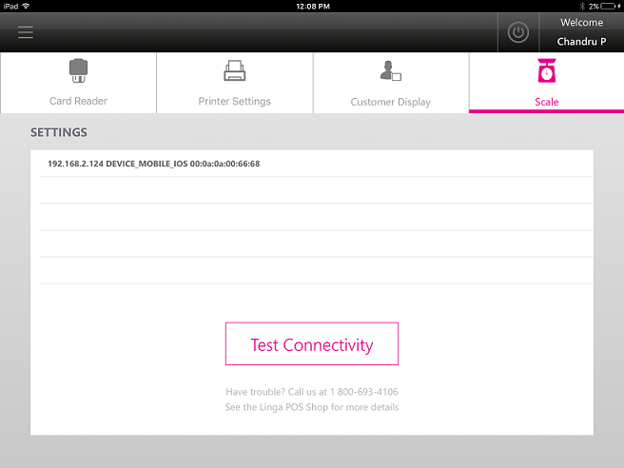

Selecting the device and test the connectivity by clicking the Test button.

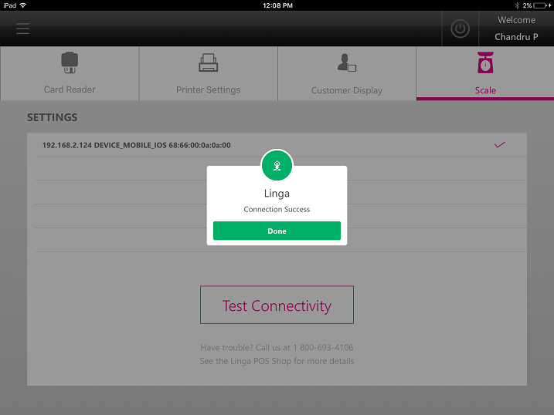

Order Scale Item
When user select the scale item, app should show the below scale measure window.
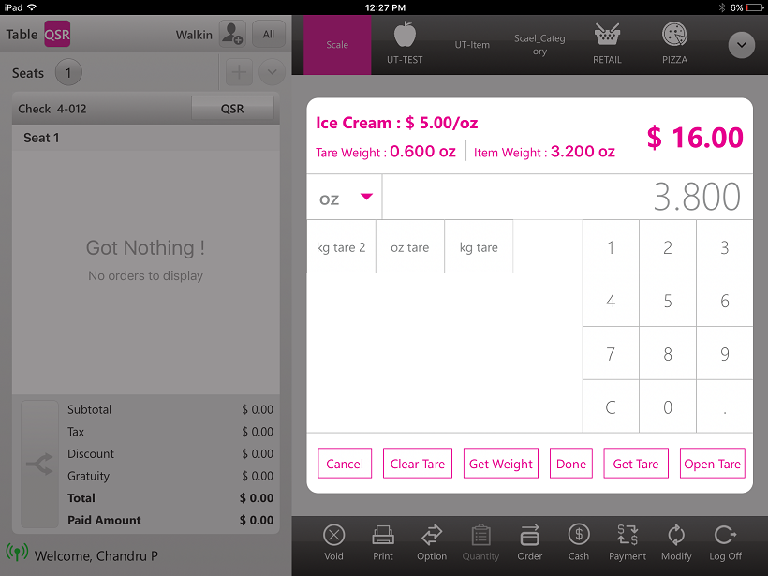

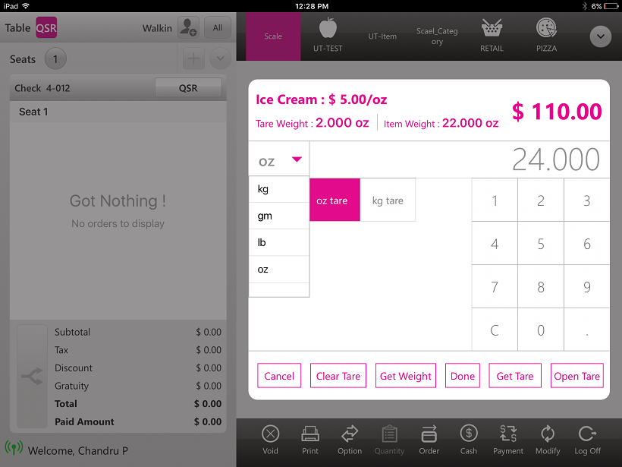

Unit
Application should have the default weight OZ, Ounce, Grams and Kilogramme. User can able to select the prefered weight type by the time of placing order. Scale device (device setting) will alway return the fixed weight type and user should able to set the same as default for iPad wise. If user select the different weight type, app should do the converstion from Device weight with selected weight type. (Note : If user select the wrong weight type, app will not responsible for it). When user changing the weight type app should show the popup say, units may have little difference while rounding. For every new menu item, screen should bring the default weight type. When user reopen the same menu item to change the weight etc, app should show the user selected weight type.

Tare Weight
Tare weight is nothing but the container weight which is used to keep the menu item (ex : Cup for yogurt). When user click the tare button, app will show the tare weight. User can create the Tare group with Tare values. Which user can attach the same

OPen Tr
This option should provide user to enter the tare weight manually. When user click the Open Tare button app should popup the number pad to enter the weight. Open tare weight will consider the selected weight type.

get TR
Here the option, should provide user to get the exact tare weight on the fly. When user keep the container in the scale device and click Get Tare button will get the take read the tare weight from device and show it in the tare weight section. Get tare weight will consider the selected weight type.

Preset Tare
Preset Tare is the predefined tare list in the BO. App should show the list of tare assigned to the particular category, sub category, menu or default tare.

Price Per QTY
It is should set in the Back office where the scale menu price setting. User can set the price for each qty. (ex : 1 Ounce = $0.5)

Price ITem
Price in the UI should be auto calculate based on the weight and price per qty set in the BO. User should not allow changing the price in the run time.

QTY
Scale device have to give the weight of the menu item which will consider as the quantity. App should do the weight conversion based on the scale setting and user selected Unit type. Since price is based in the QTY, conversion is playing the major role in the screen. App should automatically read the weight when user place the menu item in the scale and also get the weight when click the get weight button.

Done
When user click the done button, calculated price will be passed to order screen.

Menu
All the menu options will work for scale item too.
1.Hold
2.Fire
3.Void Item
4.Repeat
5.Quantity. (New Scale Get Weight screen should open for scale item)
6.Attach
7.ToGo
8.Discount
9.Open Item
10.Open Discount
11.Open Modifier

